How to download GIS data:

Please read all directions before beginning to download GIS data. Sample data for the Raquette Lake region is provided with the package. These instructions provide a detailed description of how to download the necessary data and store it properly so the worm simulation can access it successfully. If you would like to reuse some of the data from a simulation, you can copy and paste those folders into the new save folder, then repeat the download process for only the new information.

Soil:

Below are directions for how to download geo-referenced data about soil from the Web Soil Survey. First, you will download the geo-referenced key values of your unique area of interest (AOI). Then you will compile a key that associates the geo-referenced key with values of soil pH, soil depth and moisture. If you do not download the data and compile your key with the exact same AOI, then it is not guaranteed that the program will work, so it is guaranteed that you do both tasks in the same session.

1. Begin by opening the USDA Web Soil Survey (<http://websoilsurvey.sc.egov.usda.gov/App/WebSoilSurvey.aspx>)
2. After zooming to the area you would like to study, you must select and Area of Interest with the AOI tool on the Interactive Map panel. Try to keep the AOI as close to a square as possible. Note that the Web Soil Survey limits the size of AOI’s.

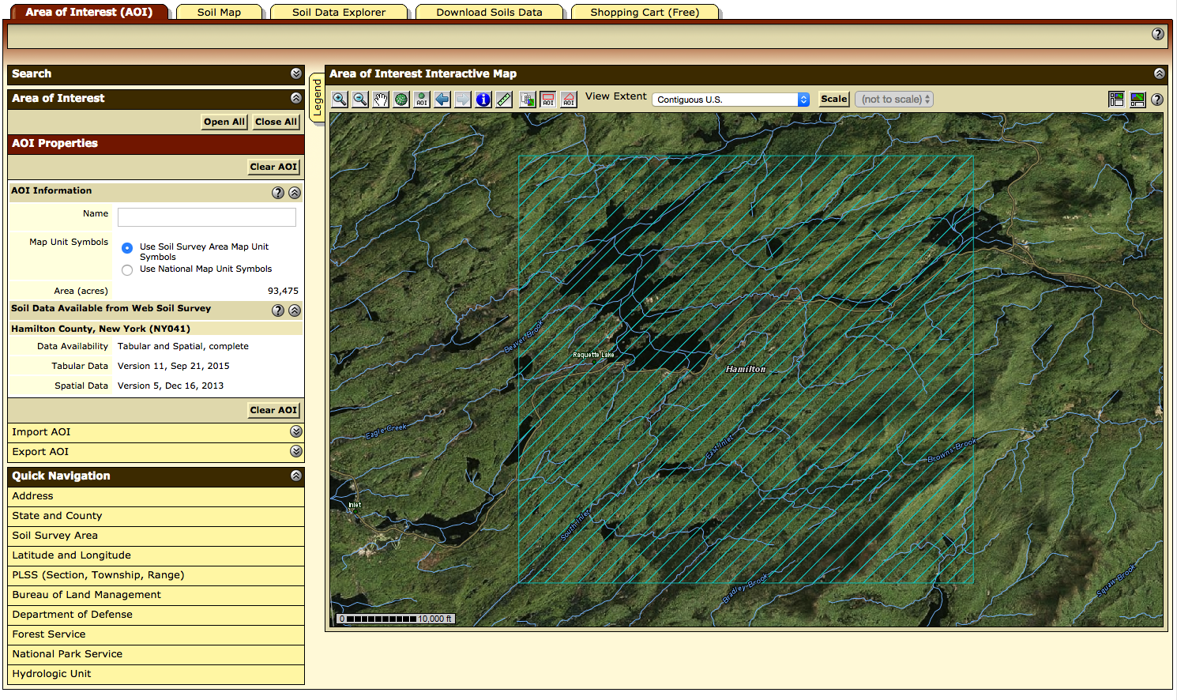

1. Once you have selected your AOI, go to the “Download Soils Data” tab and click “Create Download Link”. Once your download link has been created, download it by clicking.

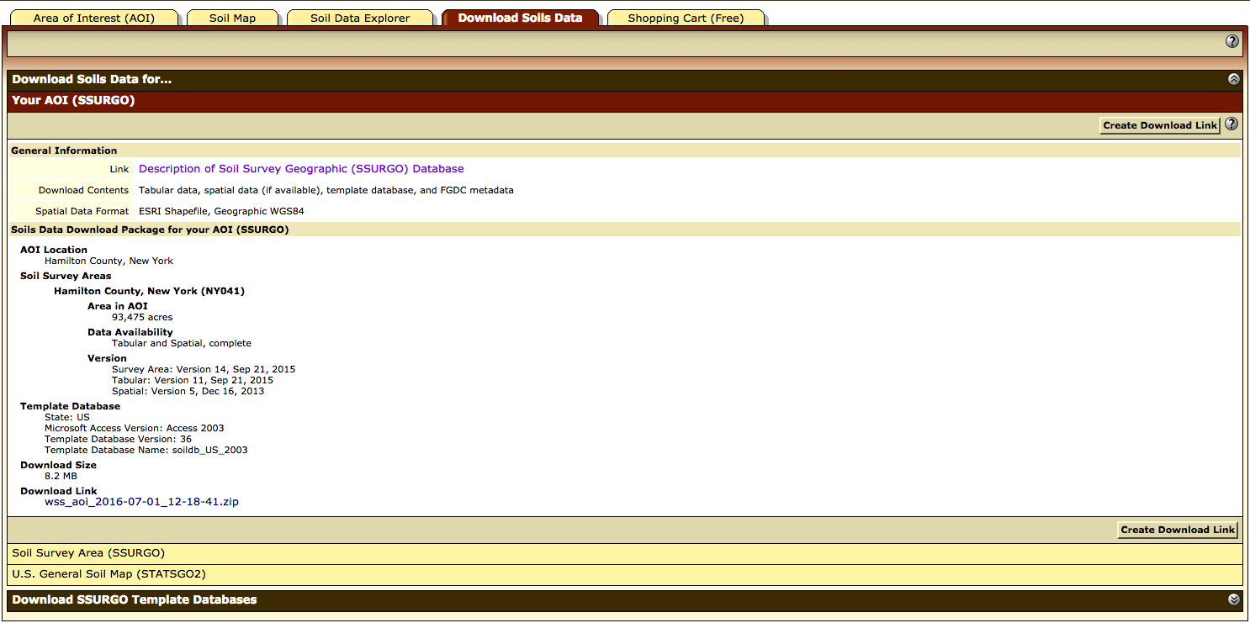

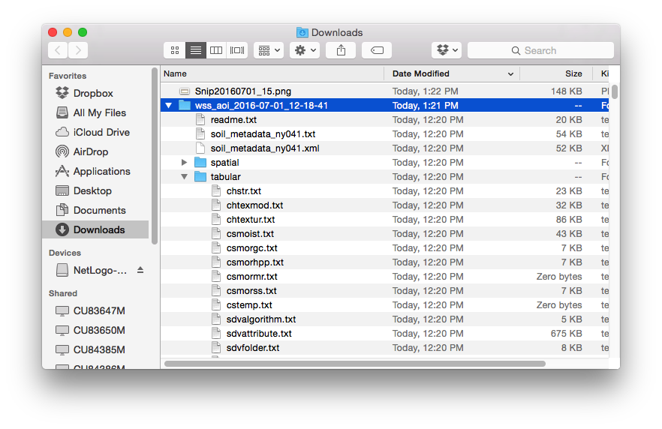

Once the file has been downloaded and unzipped, copy the “spatial” folder from the contents and paste it into the folder: simulations/*save_name*/input/soil/

When you are using a particular *save_name* for the first time, you must create the folder with that name. If you have used a *save_name­­* before, you should delete its contents (though it may be helpful to maintain the folder structure) before saving new data to it.

Note: any time *save_name* is referred to in this document, it should be replaced by the word you will be using in the *save_name* box in NetLogo to refer to the specific simulation that you are running.

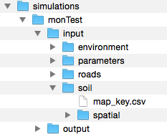

1. Next, you must create the map key. Go to the Soil Properties and Qualities Tab. When you select a trait and press “View Rating”, a table with the values of that trait will appear, as well as a key to understand the symbols on the map. Now begin by creating a file in excel, or another text editor, titled “map_key.csv”:
   1. The first column of the .csv should be the map unit symbol. It is important that this is typed just as it is in the table where it is given (the map unit symbols are case sensitive).
   2. The second column should have the map unit name
   3. The third, fourth, and fifth columns should contain the ratings for the following traits, respectively:
      1. Soil Chemical Properties -> pH
      2. Soil Qualities and Features -> Depth to Any Soil Restrictive Layer
      3. Soil Physical Properties -> Water Content, 15 bar
   4. When completed, save the file to folder: simulations/*save_name*/input/soil

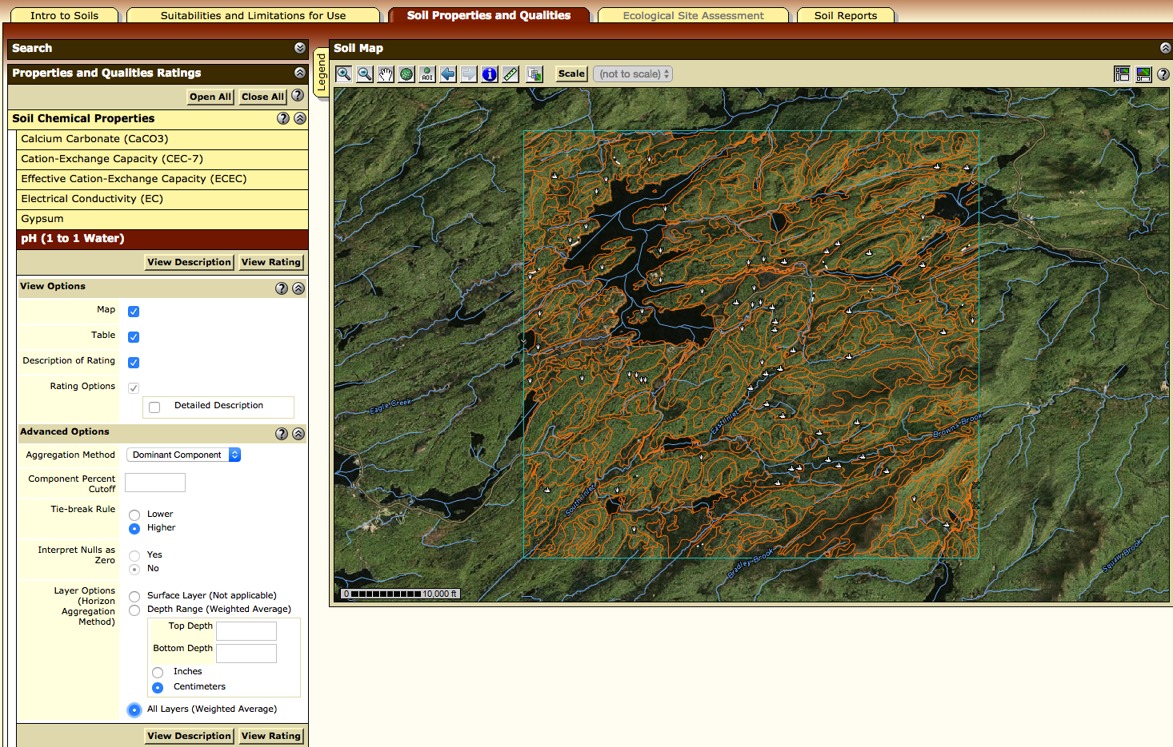

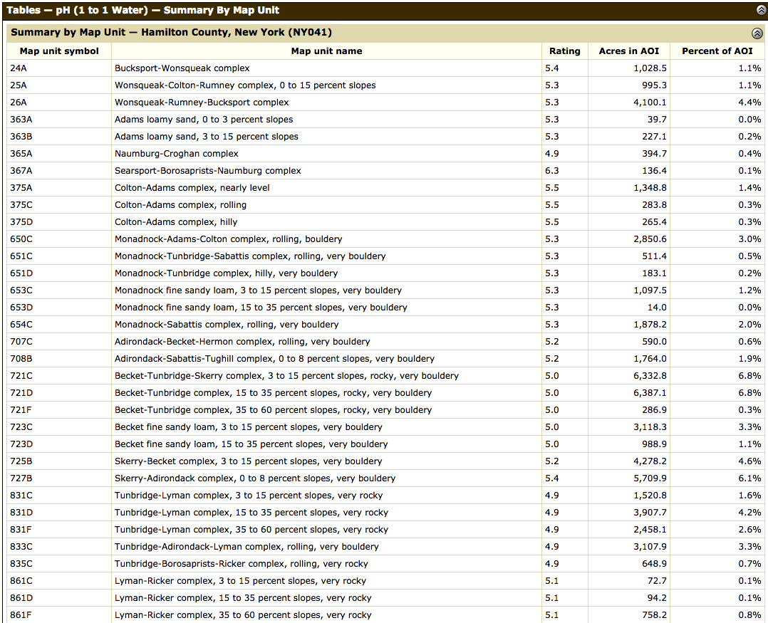

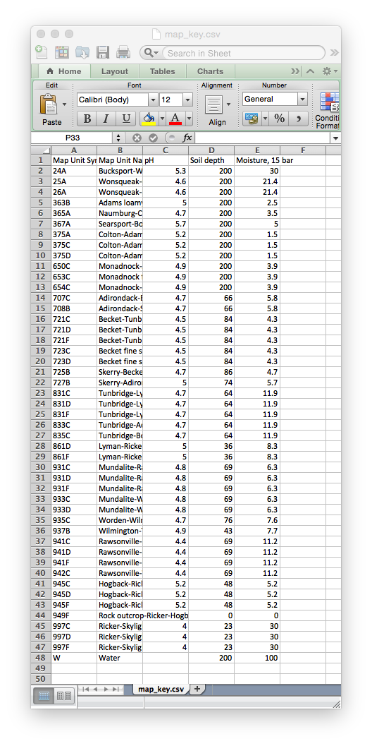

Figure: a sample of how the map_key.csv should be set up

Temperature:

In order for the simulation to work, you will need data for mean daily temperature over some scale of time. For our sample simulations we obtained historical temperature data from PRISM for the past 30 years. If you would like to change the temperature on certain days for the simulations, you can edit the .csv after you have obtained it.

1. Open the PRISM climate group’s data explorer (<http://prism.nacse.org/explorer/>)
2. Find the area that you want data for within the explorer, and select a grid within it by clicking on it
3. Adjust the settings in the window to match the settings in the picture below, within your chosen region. The start date should be January 1, but the year is up to you, depending on when/how long you would like to simulate.
4. After you have chosen the correct settings, click “Retrieve Time Series” then click “Download Time Series”
5. Once the data has been downloaded as a .csv, save it as “temperaturelist.csv” in the folder: simulations/*save_name*/input/environment/

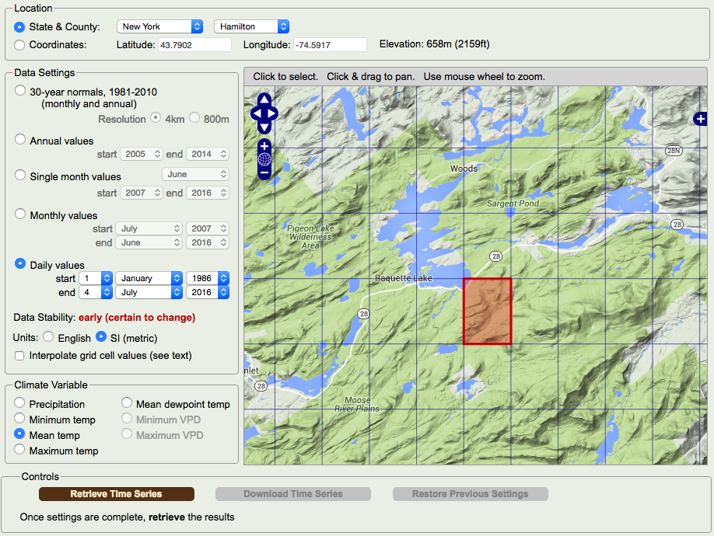

Highways:

For incorporation of major roads, we have included the ability of the worm simulator to use GIS data. There is a file available with all highways in the United States. Once you have this dataset, you can copy and paste it from one save file to another every time. If you would like to model an area extending outside of the United States, you will need to find another dataset, but the compatibility of this feature is not assured.

1. Go to the following URL to download highway GIS data <http://nationalmap.gov/small_scale/atlasftp.html?openChapters=chptrans#chptrans>
2. In the table, pull down the “Transportation” tab and find the “Roads, One-million Scale” data then download the shapefile.

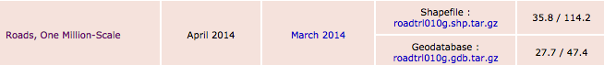

1. After downloading, copy the contents of the download to simulations/*save_name*/input/roads/ (as shown below)
2. If you have copies of the files already saved for other simulations, they can be copy and pasted into the same file path of a new *save_name*

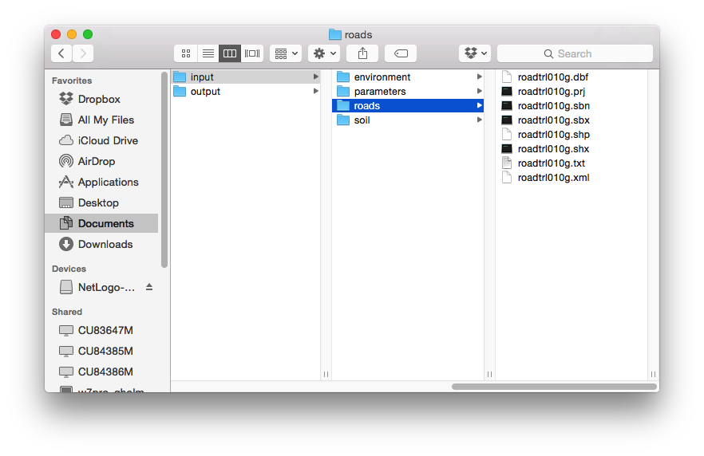

Figure: How the contents of the roads folder should appear